**

Mohammad Ali Jinnah University

Chartered by Government of Sindh - Recognized by HEC

Quiz 02

**Subject**: DBMS LAB

**Section**: BM

**Teacher**: Rimsha Javed

**Muhamad Fahad** (FA19-BSSE-0014)

(FA19BSSE0014@maju.edu.pk)

Assignment 3

Problem # 1

1. **Count the number of employees in each department. Also, display the average salary of each department.**

-- 1

select count(e.employeeID) as 'Number of employees', e.deptID, avg(j.salary) as 'Average salary' from employees e, jobs j

where e.JobId = j.JobId

Group by(e.deptID);

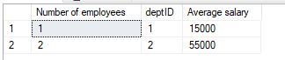

1. **Display the name, designation, and salary of the highest paid employee.**

-- 2

select e.FirstName,e.LastName,j.jobTittle,j.salary from employees e,jobs j

where e.JobID = j.JobId

and j.salary = (select max(j.salary) from jobs j,employees e

where j.JobID = e.JobId)



1. **Display the names of all the designations along with the employees assigned to that designation.**

-- 3

select j.jobTittle, e.FirstName from employees e

full join jobs j

on e.JobId = j.JobId;

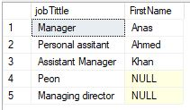

Problem # 2

1. **List of customers whose products were shipped to UK.**

use Quiz_part2;

-- 1

select * from Customers

where CustomerID in

(select CustomerID from Orders

where ShipCountry = 'UK');

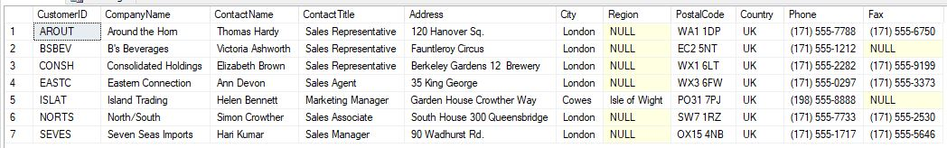

1. **Finds the shipping company (or companies) that charged the highest freight.**

-- 2

select * from Shippers

where ShipperID = (select ShipVia from Orders

where Freight = (select max(Freight) from Orders)

)



1. **Finds out all the employees who live in the same city and country as customers**

-- 3

select * from Employees

where City in (select City from Customers)

and

Country in (select Country from Customers);

